|  |  |  |  |  |
| --- | --- | --- | --- | --- |
| **National University of Computer and Emerging Sciences, Lahore Campus** | | | | |
| final design | **Course:** | **OOAD** | **Code:** | **CS-309** |
| **Program:** | **BS(Computer Science)** | **Semester:** | **Fall ’18** |
| **Duration:** | **150 minutes** | **Total Marks:** | **80** |
| **Date:** | **Friday 14-Dec-2018** | **Weight** | **40** |
| **Section:** | **B and F** | **Page(s):** | **2** |
| **Exam:** | **Lab Final** |  |  |
| **Instructions/Notes:** | **1.** Understanding the question paper is also part of the exam, so do not ask any clarification.  **2.** Make sure to switch off your mobile phones before the Exam starts.  **3.** No USB’s are allowed. Please see that the area in your threshold is clean. You will be charged for any material which can be classified as ‘helping in the paper’ found near you.  **4.** Talking/Discussion is not allowed. It is your responsibility to protect your code and save it from being copied. If you don’t protect it all matching codes are considered copy/cheating cases. Wrong submission will be marked zero.  **5.** You are not allowed to use internet for any purpose.  **6. Submit complete project named as your roll on following path:**  \\SANDATA\Xeon\Fall 2018\Asad Ullah[\OOAD\OOAD_FINAL_Submission\Sec](\\\\sandata\\xeon\\----------\\OOAD\\OOAD_FINAL_Submission\\Sec) B or F | | | |

Consider a system of Multinational Company which has 2 modules Department Data Base management system and Employee Management system.

Department Data Base management has 3 departments: Accounting, sales and HR. All the three departments can be either operational or non-operational. There is a controller who handles databases of these three departments. The Multinational can’t afford more than one controller. Hence there can be only one controller at any given time. Controller have a connection through which he/she can make operational and non-operational data bases of any three department, log information in respective data base, update log information and can close data bases. For logging information you can maintain sting list that holds the following information data base name, previous state and current state of that database (operational and non-operational). Each data base has its own list.

At the beginning of system each data base is non-operational. When controller wants to log information in a database he/she will make it operational then perform (log, update and close). If data base is already operational do not make it operational. While logging information if previous database and current data base is different change previous data base state into non-operational and then change current data base state operational. If previous and current data bases are same then do not change state of any data base. At any time only one DB can be operational. Every time you log information display all previous logs of selected database on console. (If there is any)

For example at the start of system controller chose HR data base to log. Then current log of HR data base will be: **“HR DB: non-operational: operational”**. Now controller again chose HR data base to log. Then current log of HR data base will be: **“HR DB: operational: operational”**. Next time controller chose Sales Data base and then again HR data base. Then current log of HR data base will be: **“HR DB: non-operational: operational”**. Previous state of HR data base is non-optional because sales data base make it non-operational.

The Multinational Company also has an employee management system. There are 3 types of employee’s executive employees, officer’s employees and Clerical employees. Each employee has some attributes: a unique Id, Name, age, salary. All the three types of employees can be either regular or contract. [Regular Executive employee’s salary range is “100K – 150K”], [Contract Executive employee’s salary range is “80– 100K”], [Regular Officer’s employee’s salary range is 60K – 80K”], [ Contract Officer’s employee’s salary range is “40K – 60K”],[Regular Clerical employees salary range is “30K – 60K”], [Contract Clerical employees salary range is “10K – 30K”]. You have to define an FindSalary() function that return salary accordingly.

This management System allows the CEO of the multinational company to add an employee, remove an employee and to get a specific employee. CEO add, remove or get employee according to its designation. CEO is also an executive employee (with employee id).

You need to perform following Tasks:

* Q1: Identify Design Pattern(s) used in the above mentioned case study and declare Class-Entity pairing for the applied design pattern (entity mapping) (10)
* Q2: Draw pattern specific class diagram on Star UML for the above mentioned case study (20)
* Q3: Write Java code such that an application corresponding to above mentioned requirements is created. Note that the application must not deviate much from your suggested diagram (30)
* Q4: Add Following GUIs to operate your system. (20)

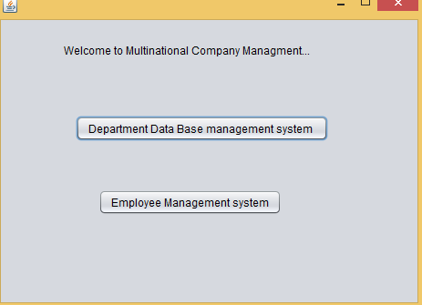

If user selects Data Base Management system then display following screen.

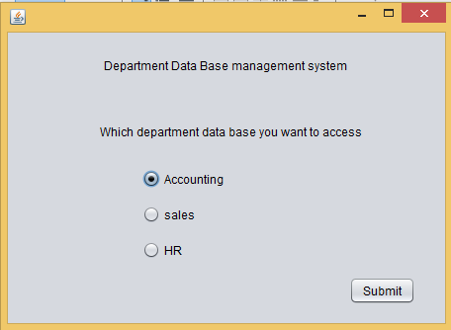

if user select Accounting data base then just following messages will print on console from open, log, close and update functions.

* Display all previous logs
* Display current log
* Display “Accounting has been closed”.
* Display “Accounting data base has updated”.

If user selects Employee Management system then display following screen.

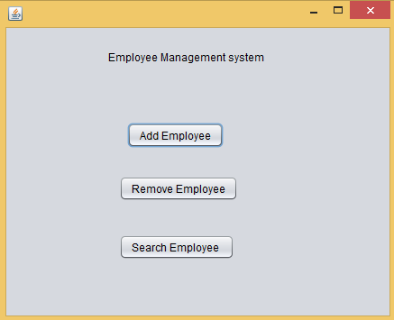

If user select add employee then following UI will displayed. Auto Assigned ID will be displayed on console.

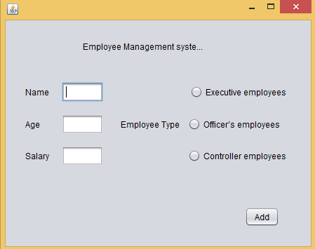

If user select remove employee then following UI will displayed if ID is invalid display message at console

